Learning Outcomes Addressed:
- Be familiar with common terms, definitions and elements related to emerging technologies.
- Research and identify emerging technologies with educational applications not yet adopted by mainstream education or in early adoption phases.
- Examine current research around technology adoption, best practices for change management and technology integration.
___________________

**Please see the section titled “Present Your Learning” located on page 4 of this seminar plan, before moving ahead.

Gamificaton Education: view the following (6:49 min)

http://www.youtube.com/watch?v=25Ph5PYsxQM

Readings: don’t despair, although there are six assigned readings they are not long

- History of Gamification in Education: Blog http://www.skilledup.com/blog/an- annotated-opinionated-history-of-gamification-in-education/
- History Infographic: http://www.edudemic.com/the-100-second-guide-to-gamification-in-education/
- NMC Horizon Report: 2012 Higher Education Edition : pgs 18-21
Game-Based Learning Time-to-Adoption Horizon: Two to Three Years
http://net.educause.edu/ir/library/pdf/hr2012.pdf
- Educause: 25 Things Teacher Should Know About Gamification
http://www.edudemic.com/25-things-teachers-should-know-about-gamification/
- Research Findings Supporting The Benefits of Gamification In Education: (read main page, linking to research documents optional) http://www.emergingedtech.com/2012/12/8-research-findings-supporting-the-benefits-of-gamification-in-education/
- 5 Stories on Educational Game Initiatives: (short stories )
http://www.gamification.co/2014/01/10/best-education-gamification-2013/
Video: view the following (54 min)
Learning 2030: Learning Through Play-(Conversation with experts in the field) http://www.youtube.com/watch?v=Ywi3TA8MuaE
- “Who says learning must be approached seriously? "Gamification" has entered the world of education. As part of The Agenda's Learning 2030 series, it's all fun and games.” Published on Feb 20, 2013
Stop here, take a breather and take the time to think about what you have learned so far.

Participation in Game Play: Please review “Blog Post” under the heading “Present Your Learning” before you move ahead.

- Now it is your turn to learn through game play. I have done some of the work for you. First I contacted a teacher that has used gamification in her classroom. She gave me a list of games with related links; to this I have added the game descriptions. I then went to the web and chose a few games I thought may interest you.

- Task: Play one game in depth or explore a few. Choose from ones I have shared or perhaps try one that was shared in the readings and videos or in a post in the Gamification folder on our Google+ site, or go on a web search for a game that you can relate to. Whatever your choice now is the time for you to see what it is like to be immersed in game play for education.

Games:
The following seven sites were shared with me by Marieke. To find out about her classes experience please read her blog post “CAN GAMING MAKE A BETTER WORLD” http://mariekehlearnsonline.weebly.com/6/previous/3.html
- Catchment Detox: http://www.catchmentdetox.net.au/ “Play Catchment Detox to see if you successfully manage a river catchment and create a sustainable and thriving economy. It's an online game where you're in charge of the whole catchment. You get to decide what activities you undertake - whether to plant crops, log forests, build factories or set up national parks. The aim is to avoid environmental problems and provide food and wealth for the population.”
- Electro City: http://www.electrocity.co.nz/Game/game.aspx “How is energy generated? How much does it cost? How does it affect the environment? These are extremely important topics today, and are no longer just the domain of engineers and industry experts. Electro City was developed to increase public awareness – particularly among students – of the basic "common knowledge" of these topics. That is, the general terms and concepts of the industry and the dilemmas that go along with them.”
- Big Farm: http://bigfarm.goodgamestudios.com/?country=US (email - user- password needed) “Big Farm is an awesome multiplayer farm management game made by the Goodgame Studios. Your mission is simple: Create a big farm, grow crops, breed animals, and become the richest farmer of the universe. Enjoy Goodgame's Big Farm!” http://www.silvergames.com/big-farm
- Garbage Dreams: http://www.pbs.org/independentlens/garbage-dreams/game.html In “Cairo the Zaballeen survive by collecting and recycling garbage. Take on the role of the Zaballeen people. Start with one neighborhood, one factory, and one hungry goat. You have 8 months to build a recycling empire and get Cairo’s total recycling as high as you can.”
- Mission Migration Game: http://www.audubon.org/games/mission-migration In the spring and the fall, many birds fly long distances in search of food, water, shelter and space: the same basic things that you need to survive. In this game you will try to help your flock migrate safely by learning how choices you make each and every day around your home, school, and neighborhood can affect the fate of these migrating birds - in both positive and negative ways. By the time you're done, you'll have the skills and knowledge to help birds thrive and survive around your home.
- Spent: http://playspent.org/ “An online game about surviving poverty and homelessness. Players must make the difficult decisions necessary to live for one month on $1,000, often having to choose between equally disagreeable options. The game ends when players either run out of money before the end of the month or make it through with money left over.” http://en.wikipedia.org/wiki/SPENT_%28online_game%29
- Windfall: http://www.persuasivegames.com/games/game.aspx?game=windfall “A strategy game about building wind farms to create clean energy profitably.
Fulfill a specified energy offset goal as quickly as possible by building turbines smartly. Research land value and average wind speeds to generate as much energy as possible with as little political consequence. When protesters start disrupting your plans, you'll have to devote some of your income to the costs of political backpedaling. The game offers three levels (easy, normal, hard), each in a different region with an increasingly larger energy goal.
Games I found at: http://www.techlearning.com/default.aspx?tabid=67&entryid=6842

- Mystery Math Museum: http://artgigapps.com/apps/mystery-math-museum “MMM is one of my all-time favorite iPad apps for Game Based Learning. This app designed for kids 6-12, has them helping a ghost rescue dragonflies throughout 8 museums by solving basic math equations. “
- Quandary: http://quandarygame.org/- “Is a free educational site/iPad app that is ideal for game-based learning. The game focuses on a student's ethical and critical thinking skills while engaging them in a sci fi/fantasy themed setting.”
- The Lost Function: https://www.atltgames.com/ “Is an in-depth math game that has students interacting with a number of characters to solve Math equations to progress further in the game. This game takes place in a fully immersive 3D environment and has students solving a wide range of problems such as: decimals, fractions, and more.”
- The Time Tribe: http://www.thetimetribe.com/ “A fun, engaging site that uses game -based learning to immerse students in adventure through the past learning about different cultures and ways of life.”
- Well Games Social: http://wellgames.com/social.html “If you enjoy playing online multiplayer games but would like to challenge your friends on social networks, boast your success in farming and building, then you have chosen the right category. We publish only casual browser games, which are family-friendly and free to play. *One of the sites where “Big Farm” is located.
Present Your Learning:
Keeping the following questions in mind as you move through the seminar material:
- Will the combination of education and gaming encourage children to embrace learning? If so, will that path lead to more students developing a lively curiosity and interest in a life-long pursuit of knowledge and skills?

How might this technology be relevant to the educational sector you know best?

What do you see as the potential impact of this technology on education?

Do you have or know of a project working in this area?
Blog Post:
- Along with looking to answer the questions above you will include a review of your gaming experience.
- How you present this learning is up to you. Look back to the many ways we have shared our learning, in previous blog posts, throughout our courses in OLTD.
- Once completed, post the link to your blog in our Google + community both in the Gamification folder and the discussion folder.
Gamification Folder: OLTD Shared Space Google + Community:
- Remember: adding posts and commenting on posts earns you points
(Resourse site: first question: http://www.youtube.com/watch?v=Ywi3TA8MuaE ;latter three questions: http://k12.wiki.nmc.org/Games+and+Gamification)
Image: http://www.seriousfactory.com/en/decryptons-vocabulaire-gamification/
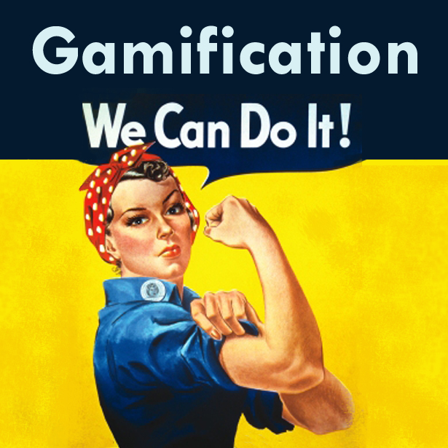

For further exploration, if you wish:

Twitter:
- #Gamebasedlearning

Google + Communities:
- Gamification in Education: “This G+ Community is geared towards exploring and sharing gamification principles, examples, and strategies for game mechanics used in educational settings.” https://plus.google.com/communities/114370132276739546873
- Gamification: “I'd like to make this a community for both those interested in learning and those interested in delving deeply into the application of game mechanics.” https://plus.google.com/communities/100524311600515505265

Gamification Websites:

Gamification Co: “is your one stop for the latest news, insight, research and commentary on gamification. Come here to find the best technology providers, read about the most exciting companies, attend one of our events and workshops, or just connect with experts.” http://www.gamification.co/about/

- Submrge - http://submrge.org “A cool new site for learning about Gamification (Game Based Learning) in the classroom. Submrge reviews recommend in detail what games are good for the classroom as well as how they can be integrated and what Common Core Standards they may be aligned to.

Gamification Site: Coming Free to Teacher January 30, 2014
- 3D Game Lab http://3dgamelab.com/personalized-quest-based-learning/

Image: http://www.coetail.com/emilykosmack/

